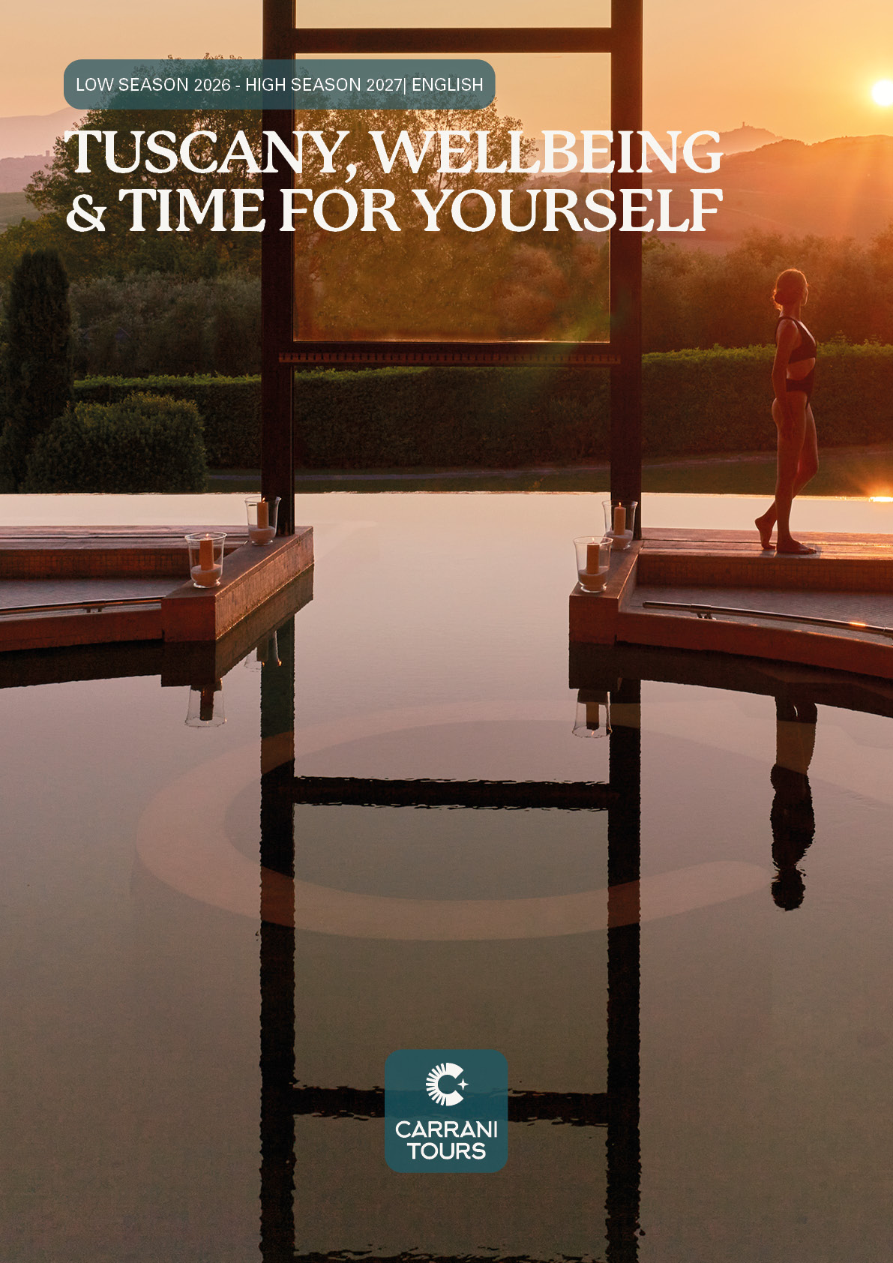

TUSCANY, WELLBEING & TIME FOR YOURSELF: 4 Days / 3 Nights in the heart of Tuscany
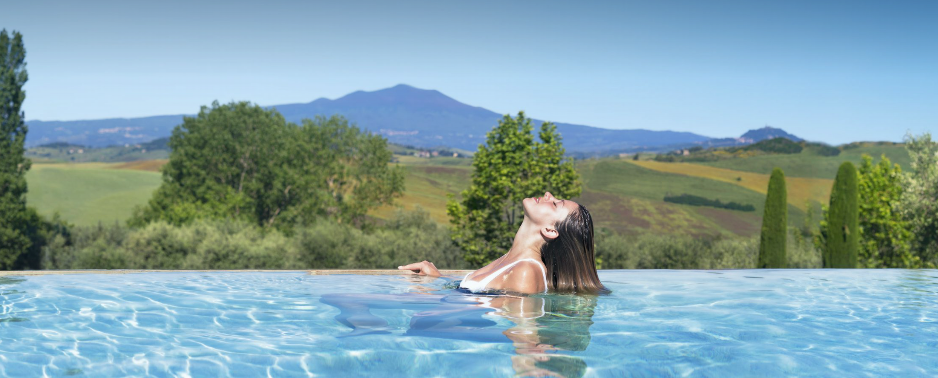
Three nights surrounded by thermal waters, nature and the unique atmosphere of the Tuscan countryside.
A sophisticated wellness retreat designed to restore balance, energy and wellbeing.
Surrounded by the rolling hills and timeless landscapes of Tuscany, Fonteverde Lifestyle & Thermal Retreat is the perfect setting for a regenerating wellness escape.
Set in a historic Renaissance residence in San Casciano dei Bagni, Fonteverde combines Tuscan elegance, natural thermal waters and a sophisticated Spa experience, creating an exclusive retreat dedicated to relaxation and wellbeing.
Package Price Low Season 2026/2027
from November 2, 2026 to March 27, 2027
Price Valid for departures From:
November 1 – December 1, 2026
December 9 – December 19, 2026
January 7 – March 27, 2027
Price per person:
- Single Room: € 2.570
- Double Room: € 1.335
Per-person supplement for departures on Thursdays and Fridays during the indicated period.
- Single Room: € 410
- Double Room: € 199
Price Valid for departures From:
December 2 - December 8, 2026
December 20, 2026 - January 6 , 2027
Price per person:
- Single Room: € 3.033
- Double Room: € 1.565

Package Price 2027

Valid for departures from March 28, 2027 to November 1, 2027
Price per person:
- Single Room: € 3.033
- Double Room: € 1.565

Special 10% Discount
A 10% discount per person applies to departures falling within the following travel periods:
- April 1 – April 27, 2027
- May 3 – May 26, 2027
- June 5 – June 29, 2027
The discount is valid only for departures starting on Saturday, Sunday, Monday, Tuesday or Wednesday within the above-mentioned periods.
Departures on Thursday and Friday are not eligible for the 10% discount.

DAY 1 – ARRIVAL & THERMAL RELAX
Arrival at Fonteverde Lifestyle & Thermal Retreat with a private transfer from Florence and check-in.
Start your stay with time to discover the resort’s thermal facilities.
Relax in the thermal pools, enjoy the natural hydro-massage waterfall and experience the Bioaquam® wellness circuit, together with the Kneipp Circuit and the Etruscan Circuit with sauna, hot plate and Turkish bath.
Time at leisure to unwind and enjoy the peaceful atmosphere of the Tuscan countryside.
Overnight at Fonteverde.

DAY 2 – WELLNESS & THERMAL EXPERIENCE
Buffet breakfast at the hotel featuring homemade cakes, local and organic products.
Start the morning with Wellness Awakening, followed by a full day dedicated to relaxation.
Enjoy unlimited time in the thermal pools and take advantage of the wellness facilities included in your stay:
- Thermal pools with natural hydro-massage waterfall
- Bioaquam® Spa Circuit
- Kneipp Circuit
- Etruscan Circuit
- Sauna
- Hot plate
- Turkish bath
- Fitness Centre
During the summer season, guests can also enjoy the outdoor swimming pool.
The rest of the day is free to relax at your own pace.
Optional Spa treatments and massages can be added upon request.
Overnight at Fonteverde.

DAY 3 – SLOW LIVING IN TUSCANY
Buffet breakfast at the hotel.
Another day to experience Fonteverde and its thermal waters in complete freedom.
Take time to slow down, enjoy the panoramic surroundings and alternate moments of relaxation in the thermal pools with the resort’s wellness circuits and fitness facilities.
Guests may also dedicate some time to discovering the atmosphere of San Casciano dei Bagni and the surrounding Tuscan countryside.
Return to the hotel and time at leisure.
Overnight at Fonteverde.

DAY 4 – WELLNESS MORNING & DEPARTURE
Buffet breakfast at the hotel.
Enjoy a final moment of relaxation and, according to the hotel’s access conditions and check-out time, one last opportunity to experience the thermal facilities.
Check-out and transfer out to Florence.
Leave Tuscany feeling relaxed, refreshed and re-energised.

THE PACKAGE INCLUDES
Private Transfer in and out from Florence
Accommodation 3 nights at Fonteverde Lifestyle & Thermal Retreat in a Superior Room with
Breakfast. Buffet breakfast including: Homemade cakes, Local products, Organic products
Thermal & Wellness Experience: Thermal pools, Natural hydro-massage waterfall, Complimentary daily Bioaquam® Spa Circuit, Kneipp Circuit, Etruscan Circuit with sauna, hot plate and Turkish bath, Wellness Awakening, Fitness Centre, Summer outdoor swimming pool.

OPTIONAL DINING EXPERIENCE
Half-board supplements are not included in the basic package price it can be added to the package
Supplement € 100 per person per dinner ( no drink included)

OPTIONAL ENHANCEMENTS
The wellness stay can be further enriched with: Massages, Spa rituals, Beauty treatmentsPersonalised wellness, treatments, Private transfers, Exclusive Tuscan experiences and excursions

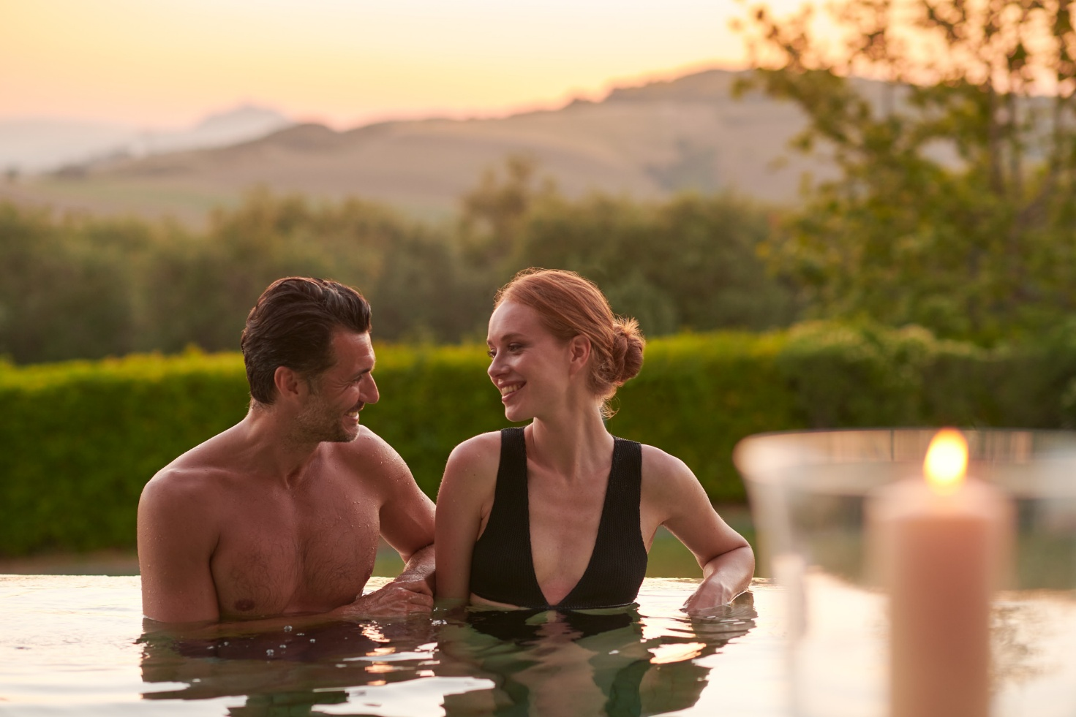

OPTIONAL EXPERIENCES
To enrich your stay at Fonteverde, guests may choose to add one of the following private experiences and discover some of the most authentic corners of Tuscany.
MONTEPULCIANO & VINO NOBILE EXPERIENCE
Half Day
Departure from Fonteverde by private car or minivan towards Montepulciano, one of Tuscany’s most fascinating hill towns, beautifully set among rolling hills and vineyards.
Time to stroll through the historic centre, among elegant Renaissance palaces, charming streets and panoramic views over the surrounding Tuscan countryside.
The experience includes a wine tasting featuring the renowned Vino Nobile di Montepulciano, offering the opportunity to discover one of the area’s most celebrated wines and its long winemaking tradition.
Return to Fonteverde.
Price per person
Includes: private car or minivan with driver + wine tasting
1 | 2 | 3 | 4 | 5 | 6
€ 677 | € 369 | € 283 | € 227 | € 194 | €189

PIENZA & BAGNO VIGNONI – VAL D’ORCIA EXPERIENCE
Half Day
Departure from Fonteverde through the breathtaking landscapes of the Val d’Orcia, one of Tuscany’s most iconic and picturesque areas.
First stop in Pienza, a Renaissance jewel and UNESCO World Heritage Site, with time to explore its charming historic centre, picturesque streets and local artisan shops.
During the visit, enjoy an included tasting of the famous Pecorino di Pienza cheese, accompanied by a glass of local wine, for an authentic taste of the flavors of the Val d’Orcia.
Continue to Bagno Vignoni, a picturesque thermal village famous for its unique historic thermal pool located in the heart of the main square.
Time for a pleasant walk through the village before returning to Fonteverde.
Price per person
Includes: private car or minivan with driver + Pecorino di Pienza cheese, accompanied by a glass of local wine
1 | 2 | 3 | 4 | 5 | 6
€ 677 | € 369 | € 283 | € 227 | € 194 | €189

PERSONALISE YOUR STAY
The experiences listed above are optional and not included in the basic package rate.
Guests can freely choose whether to add one or more experiences to their stay, combining the discovery of Tuscany with moments of relaxation and wellness at Fonteverde.

